 | 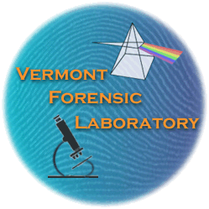 | TEL: 802•244•8788  FAX: 802•241•5557  E-MAIL: DPS.ForensicLab@vermont.gov  http://www.vfl.vermont.gov/

Vermont Forensic Laboratory Disposition of Unlawful Firearm Submission Form

I, _________________________, certify that I work for the following law enforcement agency: _______________________________________. The agency case number associated with the unlawful firearm submitted for disposition is: ___________________.

 | Name | Phone | Email Address

Investigating Official

Prosecuting Official

□ The documentation associated with the owner of the weapon and a photograph of the weapon is attached.

Make | Model | Caliber | Serial #

I have reviewed 20 V.S.A. §§ 2302 and 2303 and I, __________________________, hereby certify the below listed firearms are subject to disposal in accordance with Chapter 145 of Title 20 for the following reasons:

 | Unlawful per se
□ | Possession of the firearm is per se unlawful under federal law or state law.

 | or Unlawful
□ | Possession of the firearm is a violation of federal law or state law.
□ | The firearm was □ carried or □ used in violation of federal law or state law or in the commission of any federal or state felony.

REQUIRED FOR ALL SUBMISSIONS:

Dated this ______ day of _________________, 20____ at ___________________ County, Vermont.

____________________________

Signature

____________________________

Printed name

Chain of Custody
Received from | Date | Time | Received By

