CUSTOMER SPECIFICATIONS:
“REQUIRED FIELDS”
Please attach completed form and all job files and send to
bgs.printshoporders@vermont.gov
For instructions on filling out this form please go to
http://www.bgs.vermont.gov/gbs/print-shop/faq

Job Title:

Customer Number:

Date Required:

Contact Full Name:

Phone:

Email:

Shipping Information:
“Please Include Room/Bldg, Street and City, State, Zip+4”

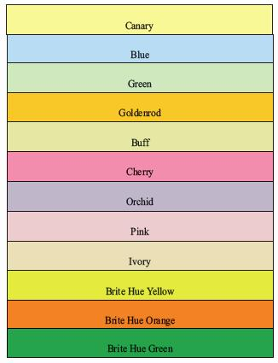
Paper colors we have in stock
JOB SPECIFICATIONS:
Please fill out as entirely as possible.
Use the special instructions field for additional paper colors or instructions.

Number of Originals:

Finished Quantity:

Finished Size:

Duplex:

Paper Color:

Paper Size:

Paper Type:

Ink Color:

Collate:

Padding: (number of sheets or sets per pad)

Laminate:

Foam Core Mounting:

Punching:

Staple:

Bind:

Tab for Mailing:

Folding:
Letter Z-Fold Half Double Parallel
Type of Mailing:

Earliest Date to Mail: Latest Date to Mail:

Special Instructions attach additional sheet if needed:

