STATE OF VERMONT  DEPARTMENT OF PUBLIC SAFETY  VERMONT FORENSIC LABORATORY  P.O. BOX 47  WATERBURY, VERMONT 05676-0047 | 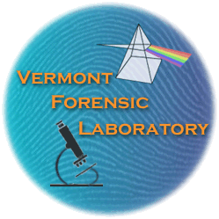 | TEL: 802•244•8788  FAX: 802•241•5557  E-MAIL: DPS.ForensicLab@vermont.gov  http://www.vfl.vermont.gov/

Vermont Forensic Laboratory Review of Unlawful Firearm Form

I, _________________________, certify that I work for the following law enforcement agency: _______________________________________. The agency case number associated with the unlawful firearm submitted for disposition is: ___________________.

 | Name | Phone | Email

Investigating Official

Prosecuting Official

□ The documentation associated with the owner of the weapon and three photographs of the weapon are attached.

Make | Model | Caliber | Serial #

I have reviewed 20 V.S.A. §§ 2302 and 2303 and I, __________________________, hereby certify the below listed firearms are subject to disposal in accordance with Chapter 145 of Title 20 for the following reasons:

Unlawful per se
□ | Possession of the firearm is per se unlawful under federal law or state law.  Or the firearm was used in a homicide.

or Unlawful
□ | Possession of the firearm is a violation of federal law or state law.
□ | The firearm was □ carried or □ used in violation of federal law or state law or in the commission of any federal or state felony.

REQUIRED FOR ALL REVIEWS:

Dated this ______ day of _________________, 20____ at ___________________ County, Vermont.

____________________________ ____________________________

Signature Printed Name

FOR VFL USE ONLY:

□ | Firearm will be retained by the VFL as part of its Reference Collection.
□ | Firearm to be transferred to BGS.

Chain of Custody
Received From | Date | Time | Received By

